Internet Of Things: Project 1 Team Report

**Project Title:** Sound Sensor Alarm System

**Group Members:** Lily Hinde, Dylan Willams, Hannah Rodtmann

**Our Trello Page:** [**https://trello.com/b/m3vlGpFZ/internet-of-things-project**](https://trello.com/b/m3vlGpFZ/internet-of-things-project)

**Our GitHub Page:** [**https://github.com/Azzizelo/Internet-of-Things-Project-1**](https://github.com/Azzizelo/Internet-of-Things-Project-1)

**Data Gathered throughout planning our project:**

These are links to websites we used to expand our idea for our project we were heading towards motion sensor, but we didn’t the equipment for it, so we planned to use a sound sensor instead:

*Akinwumi, S.A., Ezenwosu, A.C., Omotosho, T.V., Adedoyin, O.O., Adagunodo, T.A. and Oyeyemi, K.D. (2021). Arduino Based Security System using Passive Infrared (PIR) Motion Sensor. IOP Conference Series: Earth and Environmental Science, 655(1), p.012039. doi:https://doi.org/10.1088/1755-1315/655/1/012039.*

*Syazlina Mohd Soleh, S.S., Som, M.M., Abd Wahab, M.H., Mustapha, A., Othman, N.A. and Saringat, M.Z. (2018). Arduino-Based Wireless Motion Detecting System. [online] IEEE Xplore. doi:https://doi.org/10.1109/ICOS.2018.8632703.*

*Syazlina Mohd Soleh, S.S., Som, M.M., Abd Wahab, M.H., Mustapha, A., Othman, N.A. and Saringat, M.Z. (2018). Arduino-Based Wireless Motion Detecting System. [online] IEEE Xplore. doi:https://doi.org/10.1109/ICOS.2018.8632703*

*Sang, K. (2016). LED color control using Arduino and Human motion sensors. Journal of Satellite, Information and Communications, [online] 9(2), pp.69–73. Available at: https://koreascience.kr/article/JAKO201467958869123.page [Accessed 6 Mar. 2025].*

*Torsten Kröger (2011). Opening the door to new sensor-based robot applications—The Reflexxes Motion Libraries. International Conference on Robotics and Automation. doi:https://doi.org/10.1109/icra.2011.5980578*

*Magno, M., Polonelli, T., Benini, L. and Popovici, E. (2015). A Low Cost, Highly Scalable Wireless Sensor Network Solution to Achieve Smart LED Light Control for Green Buildings. IEEE Sensors Journal, 15(5), pp.2963–2973. doi:https://doi.org/10.1109/jsen.2014.2383996.*

**Outlined of the Problem to be solved:**

In this project we are designing a Sound Sensor Alarm System this outlines the problem of burglary, theft etc. With this it can detect high frequency sounds (such as glasses breaking etc) of an intruder by using a sound sensor which sets off the alarm (buzzer) notifying the individual of the intruder. This system can help secure more homes, businesses from theft.

*de Lauretis, L., Lombardi, T., Costantini, S. and Clementini, L. (2021). An Arduino-based Device to Detect Dangerous Audio Noises. Proceedings of the 6th International Conference on Internet of Things, Big Data and Security. [online] doi:https://doi.org/10.5220/0010476403030308.*

*Thilagam. J Salai Thillai, T. Sarath Babu and B. Siva Reddy (2019). Arduino based safeguarding system by using sound. doi:https://doi.org/10.1109/iccmc.2019.8819674.*

*Rajagukguk, J. and Sari, N.E. (2018). Detection System of Sound Noise Level (SNL) Based on Condenser Microphone Sensor. Journal of Physics: Conference Series, 970, p.012025. doi:https://doi.org/10.1088/1742-6596/970/1/012025.*

*de Lauretis, L., Lombardi, T., Costantini, S. and Clementini, L. (2021). An Arduino-based Device to Detect Dangerous Audio Noises. Proceedings of the 6th International Conference on Internet of Things, Big Data and Security. [online] doi:https://doi.org/10.5220/0010476403030308*

**Summary of Project:**

**Project Overview**

This project is an Internet of Things (IoT) security alarm that utilizes Arduino technology and a sound sensor to detect noise or movement. When the sensor detects a sound above a certain threshold, it sends a signal to the Arduino board, which then triggers an alarm by emitting a loud noise. This system acts as a basic security protocol, helping to alert users of potential intrusions or disturbances.

**How It Works**

Sound Detection: A sound sensor continuously monitors the environment for any unexpected noise or movement.

Signal Processing: When noise levels exceed a predefined threshold, the sensor sends a signal to the Arduino board.

Alarm Activation: The Arduino processes the signal and triggers a connected buzzer or speaker to emit a loud alarm sound.

Alert Mechanism: The alarm serves as a deterrent and notifies users of possible security threats.

**Components Used**

Arduino Board (e.g., Arduino Uno) – Acts as the brain of the system

Sound Sensor Module (e.g., KY-038 or LM393) – Detects sound changes

Buzzer or Speaker – Produces an alarm sound when triggered

Power Source & Connecting Wires – Supplies power and connects components

**Applications**

Home Security: Detects intruders and activates an alarm

Office or Store Monitoring: Alerts in case of unauthorized access

Noise Monitoring: Can be used in areas where sound levels need regulation

**Future Enhancements**

Adding Wi-Fi or Bluetooth connectivity to send real-time alerts to a mobile app

Integrating motion sensors for added security

Implementing a remote-control feature to enable or disable the alarm

This project provides a simple yet effective way to enhance security using IoT and Arduino technology

**List of Requirements:**

Outline a problem to be solved

Using sensors for the project

Research on Arduino code

Research on pervious Arduino projects

Trello page to track our projects progress

A GitHub repository to submit our code for the project

**Initial Design**

**Proposed Sketch of device**

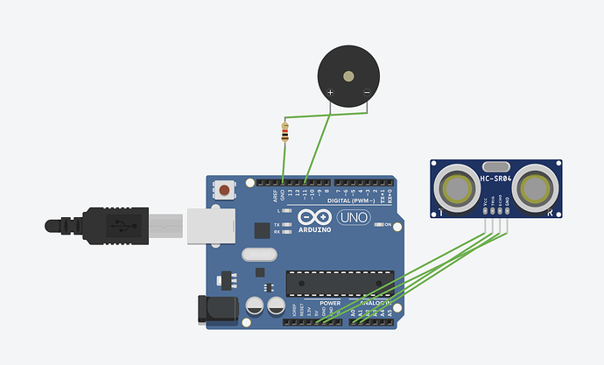

**Proposed Code Design**

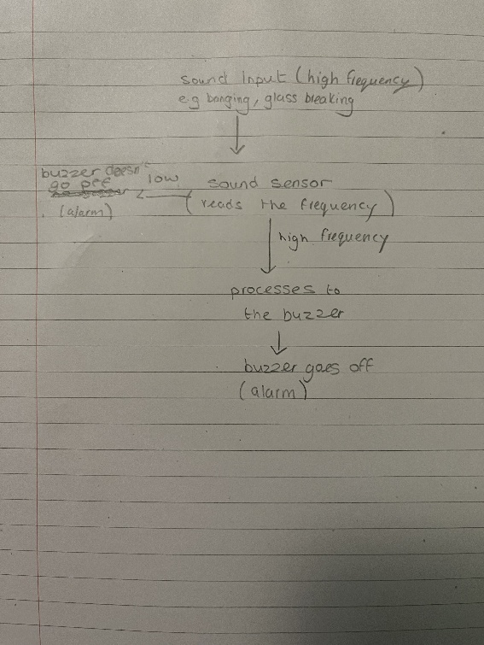

**Proposed Hardware Setup**

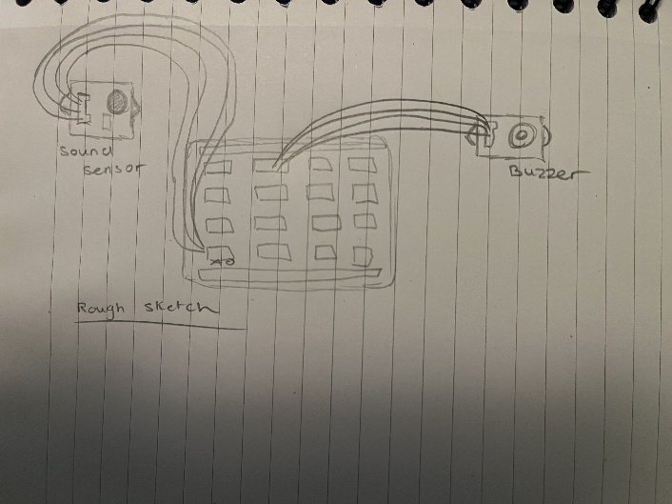

**Description of data generated, datasets or APIs used**

We used Arduino to code our device, we gave it an input it processed it and gave us an output depending on the frequency of the input.

**Stored our data**

We planned to save our code to a folder called Project 1 in our OneDrive from Arduino. We made our GitHub Team Page where we stored our code for the project.

**Implementation Plan**

|  |  |
| --- | --- |
| **Equipment Needed:** | **Parts List** |
| Sound Sensor. | USB Interface Chip |
| Buzzer. | USB Connector |
| Arduino Board. | Reset Switch |
| USB Cabel | Digital Pins |
| 2x Wires | Power Port |
| Code | TX RX LEDs |
| Grove Based Shield | Crystal Oscillator |
|  | Microcontroller |
| Voltage Regulator |
| Analog Input Pins |

**APIs Used**

Arduino Software where we coded our device.

**Images of Device**

**Testing Approach**

We planned out a problem we wanted to solve, we brainstormed a few ideas and eventually came up with the idea to make a sound sensor that warns you when the volume / frequency is too high

We then started to research on google scholar. We found and looked at several articles on the concept and how others went about creating the alarm system.

We found several instances of the project and took different approaches from several different articles. (Including some lines of code)

After the bulk of the research was done, we built the device on an Arduino emulator, after some testing making sure it worked as we intended, we moved on to make the real thing with the Arduino kit provided by our lecturer.

We built the sound sensor and Buzzer using the Arduino kit and tested it using the exact same code from the emulator, after slightly adjusting some of the code we got it working perfectly ready to be presented.

The kit now warns the user when the volume is too high and sends an alarm through the buzzer telling the user to turn down their volume.

**Security Analysis**

During the planning of our project, we used trusted websites for the research of this project to prevent unreliable information or malicious content.

In our code we have used debugging code to make sure our code runs well and no errors.

Our data of code was saved on OneDrive with only access to group members and was uploaded to our trusted GitHub team website that only individuals we approve can see our work or edit it.

**Further Improvements**

With further research and planning we can improve our device by added a motion sensor and an LED.

**First Steps**

We would first add the motion sensor to our device as it would detect motion aswell as sound which would enhance our device making it better for security. The LED would be added to warn other would aren’t able to hear the alarm this will include with individuals who are deaf or partially have hearing.

*Syazlina Mohd Soleh, S.S., Som, M.M., Abd Wahab, M.H., Mustapha, A., Othman, N.A. and Saringat, M.Z. (2018). Arduino-Based Wireless Motion Detecting System. [online] IEEE Xplore. doi:https://doi.org/10.1109/ICOS.2018.8632703.*

*Darmawan, E. and Taufan, R. (2019). Space Security System using Motion Sensor and Notification of Short Message Service with Arduino-Based Fuzzy Logic Algorithm. Journal of Physics: Conference Series, 1179, p.012034. doi:https://doi.org/10.1088/1742-6596/1179/1/012034.*